SonarQube with JACOCO

1. Download the SonarQube for windows from <https://binaries.sonarsource.com/Distribution/sonarqube/sonarqube-7.8.zip>
2. Extract the ZIP in any folder
3. Start the SonarQube By clicking on the StartSonar as shown in the below picture

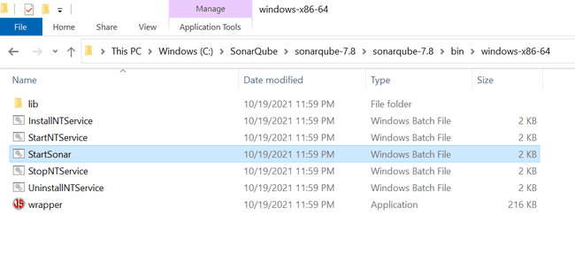

1. Open the URL <http://localhost:9000> and login to the SonarQube

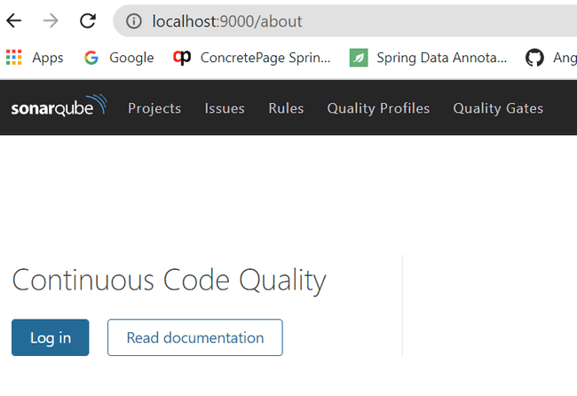

1. Provide default username and password as admin

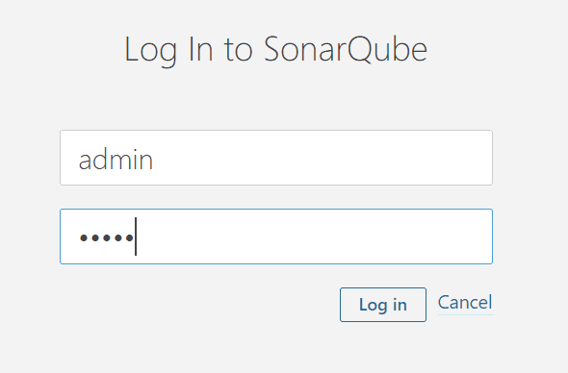

1. Create a new Project and fill the details

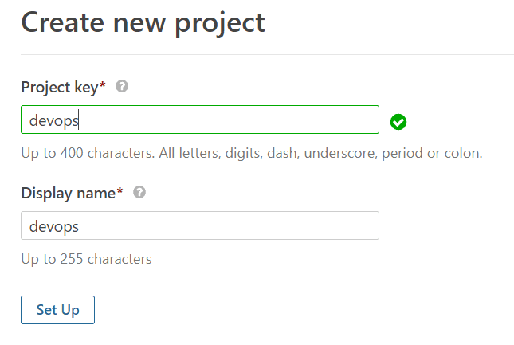

1. Generate a Token by clicking on the Generate Button and save the token for further use

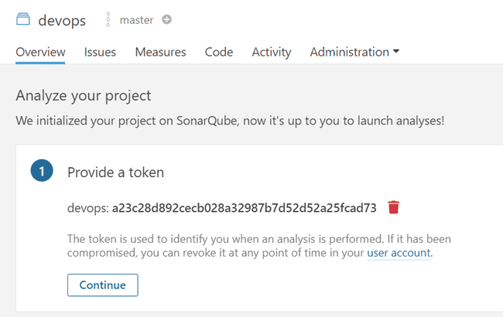

1. Now click on continue button and Select the language and the build tools

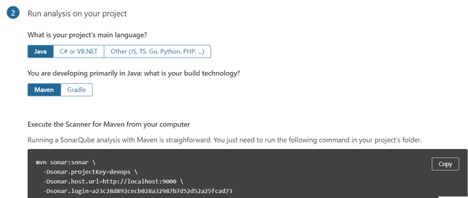

1. Now execute the mvn sonar: sonar command (above) from the project
2. After the Above command check the sonarqube to see the analysis about the project.
3. Add the below properties in the spring boot application pox.xml file

<**properties**> <!-- JaCoCo Properties --> <**jacoco.version**>0.8.6</**jacoco.version**> <**sonar.java.coveragePlugin**>jacoco</**sonar.java.coveragePlugin**> <**sonar.dynamicAnalysis**>reuseReports</**sonar.dynamicAnalysis**> <**sonar.jacoco.reportPath**>

${project.basedir}/../target/jacoco.exec

</**sonar.jacoco.reportPath**>

<**sonar.language**>java</**sonar.language**> </**properties**>

1. Add the JACOCO dependency in the pom.xml file

<dependency>

<groupId>org.jacoco</groupId>

<artifactId>jacoco-maven-plugin</artifactId>

<version>0.8.6</version>

</dependency>

1. Add the JACOCO Plugin in the pom.xml file

<plugin>

<groupId>org.jacoco</groupId>

<artifactId>jacoco-maven-plugin</artifactId>

<version>${jacoco.version}</version>

<executions> <execution>

<id>jacoco-initialize</id>

<goals>

<goal>prepare-agent</goal>

</goals>

</execution> <execution>

<id>jacoco-site</id>

<phase>package</phase>

<goals>

<goal>report</goal>

</goals>

</execution> </executions>

</plugin>

1. Now Run the mvn clean package
2. Mvn sonar:sonar
3. JACOCO Code Coverage report

